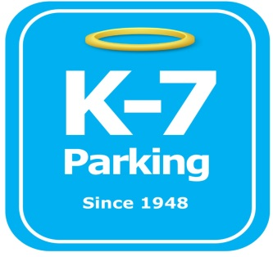 ***Find your Place in Parking Heaven with K-7!***

**UPMC Terrace St garage Screener**

**Address:** 3500 Terrace St. Pittsburgh, PA 15213

**MOM:**  412-885-4952

**Supervisor:** Brad Duceour, Mitch Mindach, Cameron Clark

**Lead:**  Jeremy Redlinger

**Type of Operation:** Screener

**Operating Hours:** M-F, 4am-5pm

**Team Member Type:** **A** level valet

**Uniforms:** UPMC shirts / hats  
 Black pants / shorts / shoes

**Smoking:** NO SMOKING PERMITED AT UPMC FACILITIES

**Requests:** [requests@k7parking.com](mailto:requests@k7parking.com)

**Payroll:**  [payroll@k7parking.com](mailto:payroll@k7parking.com)

**Claims:**  [claims@k7parking.com](mailto:claims@k7parking.com)

**Safety Concerns:**

**Weather & Traffic Flow**

* be punctual for your shift
* maintain a proper and professional appearance including proper uniform and id badge
* always display positive body language
* be aware of your work load. If you need help radio for assistance from your fellow team members
* keep your eyes on the driveway at all times
* notify lead immediately if ticket machines malfunction
* respond to radio calls in a timely manner
* redirect employees without a lease to their proper garage
* make note in appropriate binder and inform your supervisor to any circumstance when a badge out is needed or an escalated situation is occurring
* make note in appropriate binder and inform your supervisor to any circumstance when an employee badge is not working. Gather available badge information to relay to the parking office
* Be extra mindful of body language when gathering any information or redirecting a parker
* assist employees or patients as needed to ensure uninterrupted traffic flow
* always inform site supervisor or Lead when a break is needed