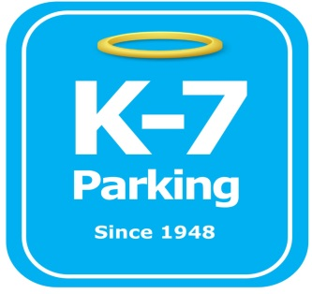 ***Find your Place in Parking Heaven with K-7!***

**UPMC Presby FALK Driveway**

**Address:** 3601 Fifth Ave. Pittsburgh, PA 15213

**MOM:**  412-885-4952

**Supervisor:** Brad Duceour, Mitch Mindach, Cameron Clark

**Lead:** Nate Piontka

**Type of Operation:** Valet

**Operating Hours:** M-F, 6am-6pm

**Team Member Type:** **C** level valet

**Uniforms:** UPMC shirts / hats  
 Black pants / shorts / shoes

**Smoking:** NO SMOKING PERMITED AT UPMC FACILITIES

**Requests:** [requests@k7parking.com](mailto:requests@k7parking.com)

**Payroll:**  [payroll@k7parking.com](mailto:payroll@k7parking.com)

**Claims:**  [claims@k7parking.com](mailto:claims@k7parking.com)

**Safety Concerns:**

**Weather, Traffic Flow, Key Security**

* be punctual for your shift
* maintain a proper and professional appearance including proper uniform and id badge
* always display positive body language
* be aware of your work load. If you need help radio for assistance from your fellow team members
* keep your eyes on the driveway at all times
* Keep driveway clear so ambulances can get in and out
* notify lead immediately if ticket machines malfunction
* obey all posted traffic signs or cones
* maintain slow speed at all times
* Ensure all keys are secured in lock boxes on vehicles at all times while in the garage
* ensure all cars are locked while in the garage
* ensure all incoming vehicles are inspected prior to parking for damage, height restrictions and or any extenuating circumstance
* offer special assistance when necessary to patients to ensure best patient experience
* accommodate requested extenuating circumstances from management.