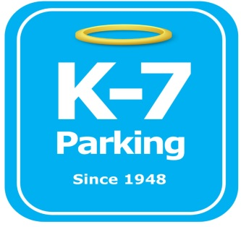 ***Find your Place in Parking Heaven with K-7!***

**UPMC Bigelow Lot (Syria)**

**Address:** 4223 Bigelow Blvd, Pittsburgh, PA 15213

**MOM:**  412-885-4952

**Supervisor:** Joe Kelley

**Type of Operation:** Valet assisted outdoor lot

**Operating Hours:** M-F 4:15am – 1am

**Team Member Type:** **B** level valet

**Uniforms:** UPMC shirts / hats  
 Black pants / shorts / shoes

**Smoking:** NO SMOKING PERMITED AT UPMC FACILITIES

**Requests:** [requests@k7parking.com](mailto:requests@k7parking.com)

**Payroll:**  [payroll@k7parking.com](mailto:payroll@k7parking.com)

**Claims:**  [claims@k7parking.com](mailto:claims@k7parking.com)

**Safety Concerns:**

**Key security, weather, lot debris, traffic flow**

* Lot is located directly across from soldiers & Sailors
* Make sure you know the traffic flow of the lot
* Pay attention to where cones have marked off safety concerns
* Check for debris at the back fences of the lot near the construction area
* Know how to properly fill out forms for new tickets.
* NEVER ACCEPT CASH!
* Be visible at all times
* Watch out for employees walking through the lot
* Be kind & curious with a smiling face at all times.