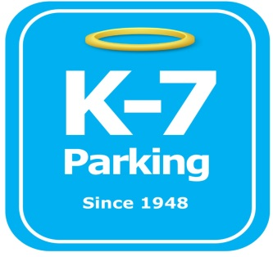 ***Find your Place in Parking Heaven with K-7!***

**UPMC South Lot B**

**Address:** 2904 Sarah St, Pittsburgh, PA 15203

**MOM:**  412-885-4952

**Supervisor:** Donald Brass

**Type of Operation:** Valet assisted outdoor lot

**Operating Hours:** M-F 5am – 11pm

**Team Member Type:** **A** level valet

**Uniforms:** UPMC shirts / hats  
 Black pants / shorts / shoes

**Smoking:** NO SMOKING PERMITED AT UPMC FACILITIES

**Requests:** [requests@k7parking.com](mailto:requests@k7parking.com)

**Payroll:**  [payroll@k7parking.com](mailto:payroll@k7parking.com)

**Claims:**  [claims@k7parking.com](mailto:claims@k7parking.com)

**Safety Concerns:**

**Weather, flow of traffic**

* Ensure all vehicles entering the lot have proper lease tags
* Walk the lot every hour to record how many empty spaces there are
* If lot if full, stack cars and handout tickets. secure all keys in the booth
* Please use the provided porta potty that is located on the lot for the restroom. If needed post a “be back in 10 minutes” sign and use the GetGo bathroom across the street.
* If need post the “be back in 10 minutes” sign to leave to get lunch
* Make sure cones are up so the shuttle has a clear path through the lot