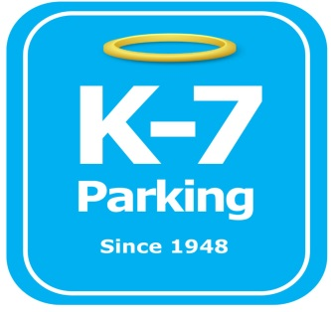 ***Find your Place in Parking Heaven with K-7!***

**UPMC Presby Cominos Lot**

**Address:** 43 Marion St. Pittsburgh, PA 15219

**MOM:**  412-885-4952

**Supervisor:** Donald Brass

**Lead:**  Ramon Valazquez

**Type of Operation:** Valet assisted outdoor lot

**Operating Hours:** Monday 4am – Friday 12am

**Team Member Type:** **B** level valet

**Uniforms:** UPMC shirts / hats

Florescent Vest (if necessary)  
 Black pants / shorts / shoes

**Smoking:** NO SMOKING PERMITED AT UPMC FACILITIES

**Requests:** [requests@k7parking.com](mailto:requests@k7parking.com)

**Payroll:**  [payroll@k7parking.com](mailto:payroll@k7parking.com)

**Claims:**  [claims@k7parking.com](mailto:claims@k7parking.com)

**Safety Concerns:**

**Weather, Traffic Flow, Exposed Railroad Spikes in lot, Key Security**

* Make sure all signs are in proper area
* keep all keys secure and hung correctly
* rest is located across the street in the medical building
* when lot is full, stack cars and hand out tickets
* When leaving the lot, please inform someone you are doing so and ensure you return promptly.