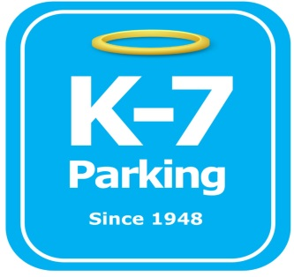 ***Find your Place in Parking Heaven with K-7!***

**UPMC Mercy Emergency Dept.**

**Address:** 1400 Locust St. Pittsburgh, PA 15219

**MOM:**  412-885-4952

**Supervisor:** Donald Brass

**Lead:** Ramon Valazquez

**Type of Operation:** Valet

**Operating Hours:** 24/ 7

**Team Member Type:** **C** level valet

**Uniforms:** UPMC shirts / hats  
 Black pants / shorts / shoes

**Smoking:** NO SMOKING PERMITED AT UPMC FACILITIES

**Requests:** [requests@k7parking.com](mailto:requests@k7parking.com)

**Payroll:**  [payroll@k7parking.com](mailto:payroll@k7parking.com)

**Claims:**  [claims@k7parking.com](mailto:claims@k7parking.com)

**Safety Concerns:**

**Weather, Traffic Flow, Key Security**

* be punctual for your shift
* always display positive body language
* be aware of your work load. If you need help radio for assistance from your fellow team members
* keep your eyes on the driveway at all times
* Keep driveway clear so ambulances can get in and out