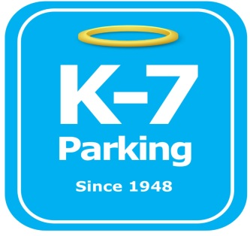 ***Find your Place in Parking Heaven with K-7!***

**UPMC Mercy Ambassadors**

**Address:** 2904 Sarah St, Pittsburgh, PA 15203

**MOM:**  412-885-4952

**Supervisor:** Donald Brass

**Lead:** Ramon Valazquez

**Type of Operation:** Greeter

**Operating Hours:** M-F 6am – 2pm

**Team Member Type:** **A** level valet

**Uniforms:** UPMC shirts / hats  
 Black pants / shorts / shoes

**Smoking:** NO SMOKING PERMITED AT UPMC FACILITIES

**Requests:** [requests@k7parking.com](mailto:requests@k7parking.com)

**Payroll:**  [payroll@k7parking.com](mailto:payroll@k7parking.com)

**Claims:**  [claims@k7parking.com](mailto:claims@k7parking.com)

**Safety Concerns:**

**Weather, flow of traffic**

* be punctual for your shift
* pick up radios at the beginning of your shift and keep them with you at all times until the end of your shift
* be very attentive and help to each and every customer
* speak clearly
* help to get tickets if customer can’t reach them
* starting with the roof, walk the garage and make sure there is space