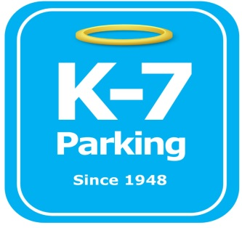 ***Find your Place in Parking Heaven with K-7!***

**UPMC Mercy Hospital Admin Lot**

**Address:** 1515 Locust St, Pittsburgh, PA 15219

**MOM:**  412-885-4952

**Supervisor:** Donald Brass

**Lead:** Ramon Valazquez

**Type of Operation:** Valet assisted outdoor lot

**Operating Hours:** M-F 6am – 6pm

**Team Member Type:** **B** level valet

**Uniforms:** UPMC shirts / hats  
 Black pants / shorts / shoes

**Smoking:** NO SMOKING PERMITED AT UPMC FACILITIES

**Requests:** [requests@k7parking.com](mailto:requests@k7parking.com)

**Payroll:**  [payroll@k7parking.com](mailto:payroll@k7parking.com)

**Claims:**  [claims@k7parking.com](mailto:claims@k7parking.com)

**Safety Concerns:**

**Weather, Traffic Flow, Key Security**

* Pick up key and walkie talkies from security
* make sure cones are in proper area including UPMC valet area
* Be aware of traffic flow
* have wheelchairs close by so they are accessible when needed
* when valeting cars, put windows up, lock doors and secure keys in the booth
* restroom is located on the 1st floor of the medical building
* When leaving the property, please inform your fellow team members and return promptly.