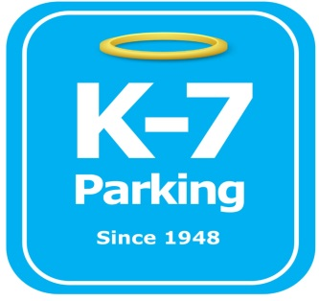 ***Find your Place in Parking Heaven with K-7!***

**River Vue Apartments**

**Address:** 300 Liberty Ave, Pittsburgh, PA 15222

**Phone:**  412-690-5147

**MOM:**  412-885-4952

**Supervisor:** Lee Volensky

**Lead:**  Josh Baker, Will Switzer

**Type of Operation:** Full valet internal / outdoor garage

**Operating Hours:** 24/7

**Team Member Type:** **C**ertified level

**Uniforms:** Grey shirts / hats  
 Black pants / shorts / shoes

**Smoking:** Off property

**Requests:** [requests@k7parking.com](mailto:requests@k7parking.com)

**Payroll:**  [payroll@k7parking.com](mailto:payroll@k7parking.com)

**Claims:**  [claims@k7parking.com](mailto:claims@k7parking.com)

**Safety Concerns:**

**Dark garage areas, car lifts, poles, height restrictions**

* Location layout:
  + Upstairs garage
  + Downstairs garage
  + Outside lifts
  + Circle
  + Ramp
* Types of customers:
  + Lease holders
  + Transient customers
  + Building residents
* Transient parking rates:
  + 0 – 2 HR: $11
  + 2 -5 HR: $14
  + 5 – 24 HR: $21
  + Early bird (in by 8am): $14
  + Saturday/Sunday: $11
* Building tenant parking rates (not valid mon-fri, 8am-5pm):
  + 0 – 6 HR: $5
  + 6 – 24 HR: $10
* All vehicles must have a lease tag, building lease tag or transient parking ticket at all times
* Large vehicles are parked on the ramp or designated truck spots
* Only cars and small SUVs are parked on inside vehicle lifts
* Be aware of using vehicle lifts (c video package “lift operations”)
* All new residents and leases have information cards listing their name, vehicle and contact information
* Building residents use the building link technology to call ahead for their vehicle
* When answering the phone, please use the following script:
  + “Thank you for calling River Vue parking, this is __________, how may I help you”
* Be aware of garage obstacles such as pillars, fans, pipes, drop ceiling overhang and vehicle lift height / width restrictions
* Park / stack cars according to customer departure time
* Vehicles that are called ahead are staged in the circle
* Employees communicate when entering and exiting garage location via walkie talkie
* Always be attentive and hospitable to all customers (a video package “conversing with customers”)