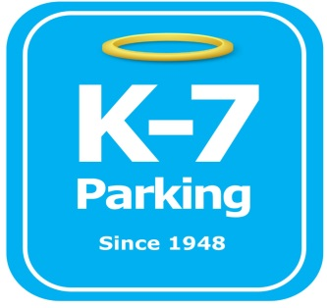 ***Find your Place in Parking Heaven with K-7!***

**The Oaklander Hotel**

**Address:** 5130 Bigelow Blvd, Pittsburgh, PA 15213

**MOM:**  412-885-4952

**Supervisor:** Joe Kelley

**Lead:** Tyler Boykin

**Type of Operation:** Full valet internal garage

**Operating Hours:** 24/7

**Team Member Type:** **C**ertified level

**Uniforms:** Oaklander specific uniforms

Black Pants / Black shoes

**Key Number**: 9021

**Smoking:** Off property

**Requests:** [requests@k7parking.com](mailto:requests@k7parking.com)

**Payroll:**  [payroll@k7parking.com](mailto:payroll@k7parking.com)

**Claims:**  [claims@k7parking.com](mailto:claims@k7parking.com)

**Safety Concerns:**

**Pillars, height restrictions, flow of traffic, entering and exiting ramps**

* “welcome to the neighborhood”
* Treat every customer and team member as part of the family
* No deviation from uniform policy is permitted
* Always display positive body language
* The Oaklander hotel is an experience. Ensure all guests have a hotel experience like no other. This starts with our first impression and superb customer service
* Be aware of tight turns going up and down garage ramps to lower and upper floors
* Garage has 3 levels:
  + Basement (59 cars)
  + 2 (44 cars)
  + 3 (50 cars)
* Hotel employees (10) are to self-park on level 3. They will have proper hang tags assigned by The Oaklander Hotel
* Vehicles exit onto Lytton Ave.
* Always keep a TEZ device on charge, usual battery life is 4-6 hours per device
* lock boxes are to stay in the garage, NOT in our visible valet area
* All Tez key tags and hang tags are to be removed and returned to the valet area after a vehicle is delivered.
* Never leave a lock box in a customer’s car. This is very damaging to our image