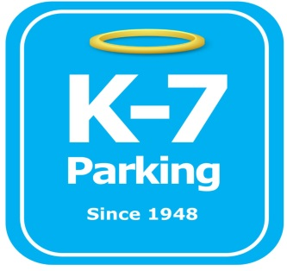 ***Find your Place in Parking Heaven with K-7!***

**Magee St. Parking lot**

**Address:** 1225 Fifth Ave, Pittsburgh, PA 15219

**MOM:**  412-885-4952

**Supervisor:** Chris Mindach

**Type of Operation:** Valet assisted outdoor lot

**Operating Hours:** M-F 7am – 3pm (Exceptions for any PPG Paints arena events)

**Team Member Type:** **B** level valet

**Uniforms:** Blue shirts / hats  
 Black pants / shorts / shoes

**Smoking:** Off property

**Requests:** [requests@k7parking.com](mailto:requests@k7parking.com)

**Payroll:**  [payroll@k7parking.com](mailto:payroll@k7parking.com)

**Claims:**  [claims@k7parking.com](mailto:claims@k7parking.com)

**Safety Concerns:**

**Public traffic, uneven surfaces, weather**

Daily

* Post proper signage with parking rate for day
* Ensure all cars have proper lease tags for that current operating month
* Any transient parkers must have a ticket on their vehicles
* When needed, double park, collect keys and secure them in the booth
* All keys are to be put in box and taken to the doubletree at closing time

Events

* Post proper signage with parking rate for event
* All vehicles are to receive a ticket for the assigned rate for the event
* Ensure all attendants are present for event lots at magee st., fisher a and fisher b
* All monies are to be taken and dropped in the back room at the doubletree for the event
* Ensure both magee st. and fisher a are aware of any prepaid parking reservations