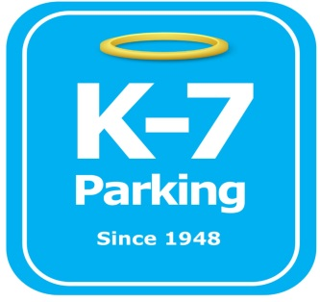 ***Find your Place in Parking Heaven with K-7!***

**Fisher B Parking lot**

**Address:** 1413 Fifth Ave, Pittsburgh, PA 15219

**MOM:**  412-885-4952

**Supervisor:** Donald Brass

**Type of Operation:** Special events valet assisted outdoor lot

**Team Member Type:** **A** level valet

**Uniforms:** Blue shirts / hats  
 Black pants / shorts / shoes

**Smoking:** Off property

**Requests:** [requests@k7parking.com](mailto:requests@k7parking.com)

**Payroll:**  [payroll@k7parking.com](mailto:payroll@k7parking.com)

**Claims:**  [claims@k7parking.com](mailto:claims@k7parking.com)

**Safety Concerns:**

**Weather, money handling, public traffic**

* All vehicles entering the lot must get a ticket with proper dollar amount based on the event we are operating for
* Vehicles must park inside the painted lines on the lot
* Signage must be posted with event rate
* All monies are to be taken and handled by Magee St. shift lead at the end of the shift
* Attendant must be visible and ready to serve the customer as they pull into the lot
* Assist vehicles into the space to ensure they are not taking up 2 spaces