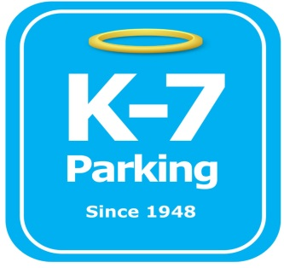 ***Find your Place in Parking Heaven with K-7!***

**DoubleTree Garage**

**Address:** 701 Centre Avenue, Pittsburgh, PA 15219

**Phone:**  412-471-2217

**MOM:**  412-885-4952

**Supervisor:** Lee Volensky

**Lead:**  Pat Mahoney, Mark Wilson

**Type of Operation:** Full valet internal garage

**Operating Hours:** 24/7

**Team Member Type:** **C**ertified level

**Uniforms:** Blue shirts / hats  
 Black pants / shorts / shoes

**Smoking:** Across street out of exit door

**Requests:** [requests@k7parking.com](mailto:requests@k7parking.com)

**Payroll:**  [payroll@k7parking.com](mailto:payroll@k7parking.com)

**Claims:**  [claims@k7parking.com](mailto:claims@k7parking.com)

**Safety Concerns:**

**Dark garage and many uneven poles, height restrictions**

* Location Layout:
  + S – Showroom
  + O – Office
  + B – Back
  + 2 – Upstairs main area
  + 2b – Upstairs back overflow
* Types of Customers:
  + Lease holders
  + Hotel guests
  + Transient customers
* Transient parking rates:
  + 0 – 1 HR: $12
  + 1 – 3 HR: $22
  + 3+ HR: $30
* Hotel guest parking rates:
  + $26 per night
  + $13 late fee (After 4pm check out)
* Team members should be aware of key security
  + Lease customers parked in S, keys go into key cabinet located in office
  + Any other vehicle gets keys stored in lock box on window
* All trucks should be parked in B on single wall
* Park / stack cars according to customer departure time
* Be aware of garage size limitations for any entering oversized vehicle
* Be aware of garage obstacles such as pillars, fans, pipes, dumpsters and pedestrian foot traffic
* Be trained on proper money handling procedures (b video package “handling money”)
* Always be attentive and hospitable to all customers (a video package “conversing with customers”)
* Always return vehicles to the location marked on the ticket, if out of place, raise windshield wiper to signal fellow team members
* Lease customers not parked in the showroom should be recorded on dry erase board in valet office
* When dealing with hotel guest’s vehicles, ask if they are returning or checking out
* be aware of a clear exit / staging area
* Always honk horn when taking vehicles to and from different sections of the garage
* Use appropriate hotel garage signs such as garage full, one vehicle per room, event rate and evening rate